Mustang Rules
(Revised Nov 2019)
Play is governed by the Official Rules of Major League Baseball and the PONY Baseball Rules and Regulations. The following outlines MBA-specific clarifications of and exceptions to PONY Rules.
A. PLAYING FIELD
- Distance between bases: 60 feet
- Pitching Distance: 46 feet
- The home team is responsible for the preparation of the field for play and the cleaning of the field upon conclusion of the game.
B. EQUIPMENT
- Wooden, metal, graphite or ceramic bats, manufactured specifically for baseball play, which are round and not more than two and five-eighths inches in diameter at the thickest part, nor more than 42 inches in length, are acceptable. The USSSA 1.15 or USA stamp must be visible.
- Metal cleats or spikes are not permitted.
- The batter, players in the on-deck circle, base runners, and players coaching in the baseline coaching boxes shall be required to wear a batting helmet.
- Catchers are required to wear proper protective equipment including a mask, chest protector, shin guards and headgear. Any player serving as a catcher to warm up a pitcher shall wear a mask.
- Catchers must wear a catcher’s glove at all times.
- Bats are to be kept inside the dugout, with the exception of the bat the on-deck batter is using. Bats may not be left against the fence.
C. PARTICIPATION
- The entire roster of players present for the game shall bat in rotation.
- There is unlimited substitution (see below for specific rules regarding pitching).
- Once removed from the lineup a pitcher may return to the lineup but shall not pitch again in the same game.
- All players must play four defensive innings. A manager who has made timely substitutions in a game which is shortened for any reason is not in violation of this rule.
- A late arriving player will be inserted at the end of a line-up.
- Failure to field eight players at least 15 minutes subsequent to game time will result in a forfeit. Once the game has started if because of injury or players leaving, a team falls below eight players, a game will continue.
- An official lineup card must be presented to the opposing team’s scorekeeper prior to the game. Scorekeepers or coaches should notify the umpire if a player is batting out of order.
D. PLAYING RULES
- During the first half of the season, base runners may NOT lead off, but they can steal any base after the ball has crossed home plate. During the second half of the season, base runners may lead off and steal at their discretion.
- Base runners can advance on overthrows in play. Two bases if it enters the dugout or goes out of play. The one they are going to, plus one.
- The runner is only required to slide at the plate if there is a play there. If a play is being made at home plate, the runner must slide or attempt to avoid a collision with the fielder or they are out. Determination of whether or not a play was being made shall be made by the umpire and shall be the basis for determining whether the runner is safe or out. If, in the opinion of the umpire, a runner intentionally collides with the fielder while not attempting to slide, the runner is out and ejected from the game.
- A batter is out when they have three strikes, either called or swinging. The catcher does not have to catch the third strike for the batter to be out – First half of season only.
- A batter is out when they have three strikes, either called or swinging. The catcher must catch the third strike for the batter to be out. If the catcher does not catch the third strike and first base is unoccupied, the batter must be tagged or thrown out – Last half of season and post season tournament only.
- All coaches must remain by the dugout or in the coaching boxes throughout the game. Coaches cannot be located behind or around the catcher or along the foul lines in the outfield. Also, other than the base coach, coaches shall remain on their side of the field.
- There is no 10-run or wipeout rule.
- Coaches cannot touch the players on the field or running the bases.
- When a team is at bat, only one player may be in the on-deck circle and they must be wearing a helmet. The balance of the team must remain in the dugout in a mannerly fashion.
- A batter who unintentionally throws a bat will receive a warning; a second occurrence will result in the batter being called out. A batter who intentionally throws a bat or helmet will be called out without a prior warning and is subject to immediate ejection from the game at the discretion of the umpire.
- Disciplined players must be announced before the game with the reason for the disciplining.
- Rescheduling of games is not permitted except for reasons of weather, field conditions, or in rare instances at the discretion of the League Vice President. Requests or rescheduled games must be submitted to the League Vice President. Prior to the start of a game, cancellation due to weather or field conditions is by mutual consent of both teams’ managers, keeping in mind the safety of the players. Once the game has begun, cancellation is under the authority of the umpires.
- The home team’s scorekeeper is always the official scorer for the game.
- Official game: An official game is 6 innings or no new inning starting after two hours from the start of the game. In case of a tie after two hours, only one extra inning is allowed to break the tie. The last out of the previous inning determines the two-hour time. If a game is tied at the end of six innings, and the game is still under the two-hour time limit, three more innings can be played as long as the total game does not exceed the two-hour time limit. If the two-hour limit is reached and the game is tied only one additional inning may be played after the two-hour limit. If the game is still tied at that point, it is recorded as a tie. Umpires are to notify the coaches and scorekeeper prior to game time, the actual starting time, as watch times vary from person to person.
- If a game is called for any reason, it shall be a complete game if 4 innings have been completed, or if the home team has scored more runs in 3 innings or three and a fraction innings, than the visiting team has scored in 4 completed innings.
16. There are no balks or infield fly rules.
A ball which rolls or bounces across the path on JM field #6 is a ground rule double. If the ball hits on or over the path on the fly, it is a homerun. A ball which rolls, bounces or flies into the right field weeds on field #7 is a ground rule double. A ball which flies into the weeds on field #2 is a home run. A ball which rolls or bounces into the weeds on field #2 is a ground rule double.
E. PITCHING RULES
- A combination of Pony Rules, MBA Rules and Pitch Smart Guidelines will govern all pitching rules.
- Any team member may pitch, subject to the restrictions of the pitch count and rest requirements as recommended by Pitch Smart Guidelines for 9-10 year olds.
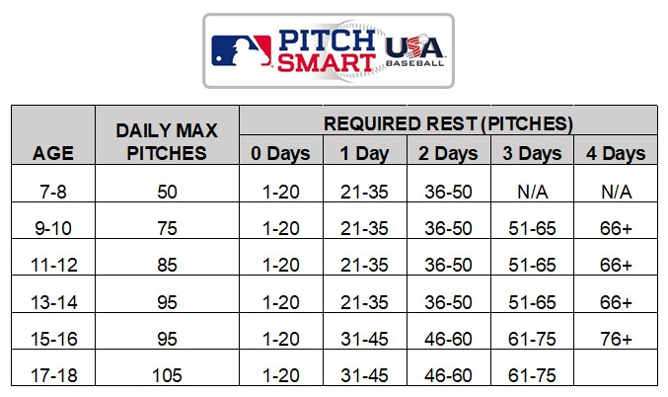
- First half of season: Pitchers shall not pitch in more than two innings on the same calendar day. Second half of season (including post season tournament): Pitchers shall not pitch in more than three innings on the same calendar day. (MBA Rule)
- When pitching in more than one game on the same calendar day, pitchers may pitch any combination of innings in those games provided they do not exceed the above maximum number of innings in a calendar day. (PONY Rule 10.E.)
- As soon as a pitcher delivers one pitch to a batter the pitcher shall be considered as having pitched in one inning. (MBA Rule)
- Any pitcher withdrawn from the mound and/or lineup, or a pitcher who is withdrawn from the mound and stays in the game at another position, shall not be permitted to pitch again in the same game. (PONY Rule 10.I.)
- Pitchers at the Mustang level are not allowed to throw curve balls. (MBA Rule)
- The pitcher may bring their pitching hand in contact with their mouth or lips while in the pitching circle as long as they wipe off their hands or fingers prior to making contact with the pitching rubber. (PONY Rule 10.M.)
- If a relief pitcher comes in “cold” the umpire shall allow the pitcher to warm up properly with at least ten warm up pitches. (Pony Rule 10.J.)
- Each team is to report the game score and the pitch count for their pitchers for each game to the league commissioner.

